1. Data store component (DSS tables)
1.1. Description of Tel Aviv Museum of Arts System
The Tel Aviv Museum didn’t really have any information system in place
The new information system is designed for a small gallery. The system will improve the performance and communication by using an integrated and uniform system that will support the information system.
In short, describe what
is the focus of your organization / business / solution

1.2. ER diagram
 | COLLECTION
PK | Collection_ID
FK | Artist_ID
 | Collection_Name

 | CITY
PK | City_Code
 | City_Name
 | City_Postal_code

 | CLIENT
PK | Client_ID
FK | City_Code
 | Client_Initial
 | Client_LName
 | Client_RSA_ID
 | Client_Cell
 | Client_Email
 | Client_Street_Adress
 | Street_Nr

 | SALES_TRANSACTION
PK | Transaction_ID
FK | Client_ID
 | Sales_Date
 | Comission
 | VAT
 | Delivery_Method
 | Sales_Total

 | SALES_TRANSACTION_DETAIL
(PK)(FK) | Transaction_ID
(PK)(FK) | Artwork_ID
 | Sales_Price

 | ARTWORK
PK | Artwork_ID
FK | Collection_ID
FK | Medium_Code
 | Artwork_Title
 | Artwork_DOC
 | Length_cm
 | Length_cm
 | Artwork_Status
 | Artwork_Established_Value

 | MEDIUM
PK | Medium_Code
 | Medium_Description

 | ARTIST
PK | Artist_ID
FK | Bank_Code
 | Artist_Initial
 | Artist_LName
 | Artist_RSA_ID
 | Artist_Cell
 | Artist_Email
 | Artist_Account_No
 | Artist_DOB
 | Artist_DOD

 | BANK
PK | Bank_Code
 | Bank_Name

1..1
has
1..*

lives in
1..*
is created
1..1
has
1..*
belongs to
1..1
includes
1..* made from
1..1 used by
1..1 contains
1..* belongs to
1..*
have
1..1
is part of

1..* was created by
1..1 creates
1..*
uses
1..1
has

1.3. Information needed for business decisions and star schemes
Scenario 1:
Required information scenario 1: Display total sales transaction per year per month per artist.
DIMENSION | DESCRIPTION | POSSIBLE ATTRIBUTES
Time  - Year  - Month  Artist | - Year and month don’t require additional dimension table  - Artist required addition dimension table, because more info is required from artist than just the Artist_ID | Shown in table below

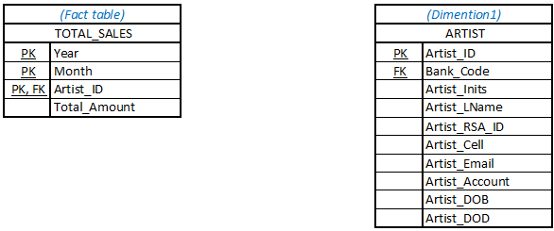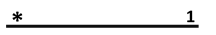
SQL to populate table TOTAL_SALES
INSERT INTO total_sales
(SELECT EXTRACT(YEAR FROM st.sales_date) AS “Year”, EXTRACT (MONTH FROM st.sales_date) As “Month”, c.artist_id, SUM(st.sales_total) AS “Total_Amount")
FROM sales_transaction st
JOIN sales_transaction_detail std
USING (transaction_id)
JOIN artwork a
USING (artwork_id)
JOIN collection c
USING (collection_id)
GROUP BY EXTRACT(YEAR FROM st.sales_date), EXTRACT (MONTH FROM st.sales_date) ,c.artist_id;

Output:

Scenario 2:
Required information scenario 2: Display the top 5 artist per year per month.
DIMENSION | DESCRIPTION | POSSIBLE ATTRIBUTES
Time  - Year  - Month  Artist | - Year and month don’t require additional dimension table  - Artist required addition dimension table, because more info is required from artist than just the Artist_ID | Shown in table below

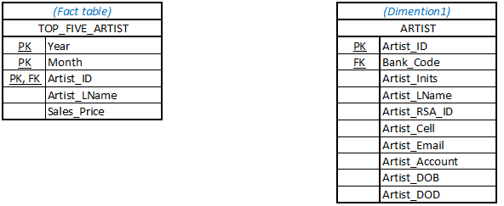
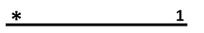
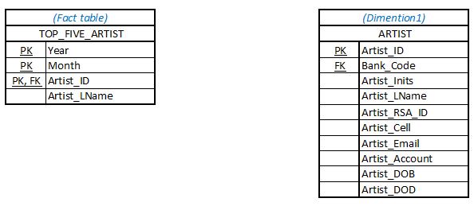

SQL to populate table TOP_FIVE_ARTIST
INSERT INTO top_five_artist
(SELECT TOP 5, EXTRACT(YEAR FROM st.sales_date) AS “Year”, EXTRACT (MONTH FROM st.sales_date) AS “Month”, a.artist_id, a.artist_lname, std.sales_price)
FROM sales_transaction st
JOIN sales_transaction_detail std
USING (transaction_id)
JOIN artwork a
USING (artwork_id)
JOIN collection c
USING (collection_id)
JOIN artist a
USING (artsist_id)
GROUP BY EXTRACT(YEAR FROM st.sales_date), EXTRACT (MONTH FROM st.sales_date) ;

Output:

Scenario 3:
Required information scenario 3: Display the top 5 devoted clients per year per month.
DIMENSION | DESCRIPTION | POSSIBLE ATTRIBUTES
Time  - Year  - Month  Client | - Year and month don’t require additional dimension table  - Artist required addition dimension table, because more info is required from client than just the Client_ID | Shown in table below

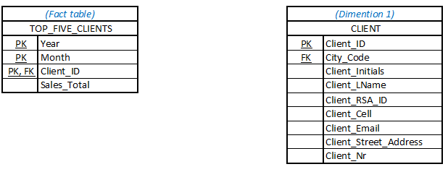
INSERT INTO top_five_clients
(SELECT TOP 5, EXTRACT(YEAR FROM st.sales_date) AS “Year”, EXTRACT (MONTH FROM st.sales_date) AS “Month”, st.client_id, std.sales_price)
FROM sales_transaction st
GROUP BY EXTRACT(YEAR FROM st.sales_date), EXTRACT (MONTH FROM st.sales_date) ;

Output

Scenario 4:
Required information scenario 4: Display the top 15 medium per year per month.
DIMENSION | DESCRIPTION | POSSIBLE ATTRIBUTES
Time  - Year  - Month  Medium | - Year and month don’t require additional dimension table  - Artist required addition dimension table, because more info is required from medium than just the Medium_Code | Shown in table below
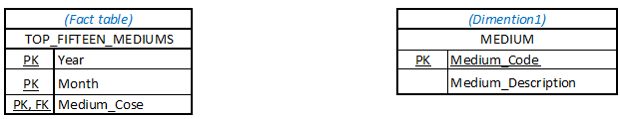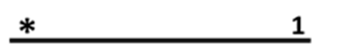

SQL to populate table TOP_FIFTEEN_MEDIUMS
INSERT INTO top_fifteen_mediums
(SELECT TOP 15, EXTRACT(YEAR FROM st.sales_date) AS “Year”, EXTRACT (MONTH FROM st.sales_date) AS “Month”, a.medium_code)
FROM sales_transaction st
JOIN sales_transaction_detail std
USING (transaction_id)
JOIN artwork a
USING (artwork_id)
GROUP BY EXTRACT(YEAR FROM st.sales_date), EXTRACT (MONTH FROM st.sales_date);

Output:

Scenario 5:
Required information scenario 5: Display the top 5 delivery locations(city) per year per month.
DIMENSION | DESCRIPTION | POSSIBLE ATTRIBUTES
Time  - Year  - Month  City | - Year and month don’t require additional dimension table  - Artist required addition dimension table, because more info is required from city than just the City_Code | Shown in table below
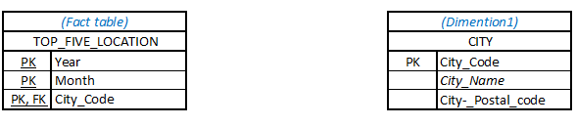
SQL to populate table TOP_FIVE_LOCATION
INSERT INTO top_five_location
(SELECT TOP 5, EXTRACT(YEAR FROM st.sales_date) AS “Year”, EXTRACT (MONTH FROM st.sales_date) AS “Month”, cl.city_code
FROM sales_transaction st
JOIN client cl
ON (st.client_id = cl.client_id)
GROUP BY EXTRACT(YEAR FROM st.sales_date), EXTRACT (MONTH FROM st.sales_date);

Output:

Scenario 6: Die star scheme is gemodify
Required information scenario 6: Display the average age per client per year per month
DIMENSION | DESCRIPTION | POSSIBLE ATTRIBUTES
Time  - Year  - Month | - Year and month don’t require additional dimension table  - No additional fact tables is required since only the average age of all customers are calculated and displayed per year per month | Shown in table below

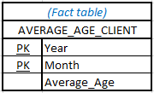

SQL to populate table AVERAGE_AGE_CLIENTS
INSERT INTO average_age_clients
(SELECT EXTRACT(YEAR FROM SYSDATE) AS “Year”, EXTRACT (MONTH FROM SYSDATE) AS “Month”,
AVERAGE(TO_CHAR(SUBSTR(client_rsa_id,1,2),’YYYY’)-TO_CHAR(EXTRACT(YEAR FROM SYSDATE),”YYYY”) AS “Average_Age”)
FROM client
GROUP BY EXTRACT(YEAR FROM SYSDATE), EXTRACT (MONTH FROM SYSDATE);

Output:

Scenario 7:
Required information scenario 7: Display the total debt per year per month per client.
DIMENSION | DESCRIPTION | POSSIBLE ATTRIBUTES
Time  - Year  - Month  Client | - Year and month don’t require additional dimension table  - Client required addition dimension table, because more info is required from artist than just the Client_ID | Shown in table below

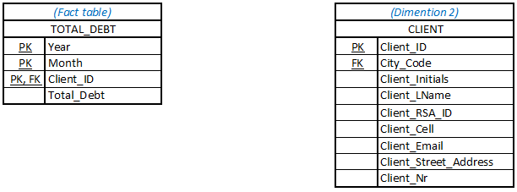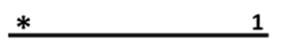
SQL to populate table TOTAL_DEBT
Debt is nerens ingesluit nie

Output:

Scenario 8:
Required information scenario 8: Display the total inventory per year per month per collection.
DIMENSION | DESCRIPTION | POSSIBLE ATTRIBUTES
Time  - Year  - Month  Collection | - Year and month don’t require additional dimension table  - Collection required addition dimension table, because more info is required from artist than just the Collection_ID | Shown in table below

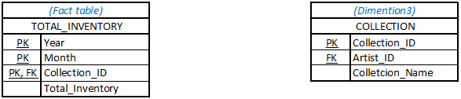
SQL to populate table TOTAL_INVENTORY
INSERT INTO total_inventory
(SELECT EXTRACT(YEAR FROM SYSDATE) AS “Year”, EXTRACT (MONTH FROM SYSDATE) AS “Month”, collection_id,
COUNT(artwork_id) AS “Total_Inventory”)
FROM sales_transaction_detail std
JOIN artwork a
USING (artwork_id)
GROUP BY EXTRACT(YEAR FROM SYSDATE), EXTRACT (MONTH FROM SYSDATE), collection_id; ;

Output:

1.6. Create DSS tables
SQL statements used to create DSS tables
- SQL for
- create tables (minimum 4)
- constraints (primary keys, foreign keys)

